In this video what we are going to do some mechanism so that the ball move for the vey first time. It only starts moving when we click on the screen first time and then it get velocity and then it starts moving
So now first we declare a bool variable names started
It will take care of if the game has started or not
and if it has started then it will add velocity to the ball otherwise don't add velocity of the ball
so in our Update method if our game has started ( means when started is false as not operator is attached on it ) then we will initialise the velocity of the ball if there was a click on the screen first time if it is not initialized then the logic of Switch direction wwill not work because no condition will be true for it as x and z velocity of the ball will be zero due to which all the condition of switch direction will be false
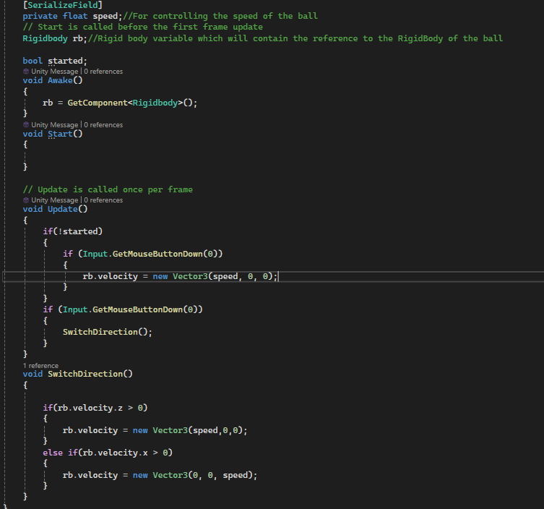
but the problem with this code is that now it will not change the direction when a click or touch was done on the screen
Because as the started is false so the condition becomes true so there are two input methods in the update as shown above and the first input's getMouseButtonDown manage the click due to which second getmouseButtonDown will return false as the click was handled by the first getmouseButtonDown
so now inside the condition of first click we will this time turn started to true due to which the first touch condition became will be false and started has become true and the control flow will not reach the first Input getMouseButtonDown and now the click will be handled by the second input getmouseButtonDown due to which this time the direction will change so teh code is shown below
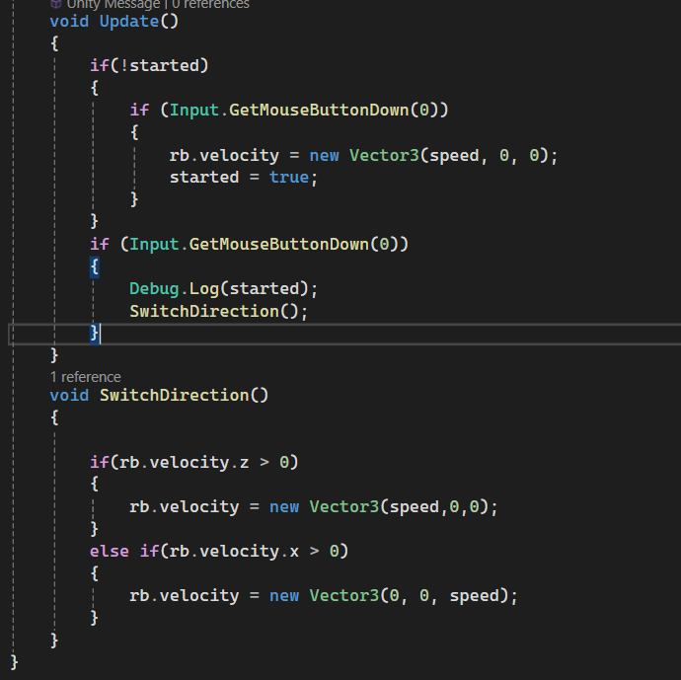
we can also set started to false in start method (optional)

Now move the camera such that the game panel and the scene panel looks almost similar
so to do that we will first move around in the scene panel and then come to position from where we want to see in our game panel
So we need to do something such that the position from where we are seeing the object in the scene panel should be same in game panel such that the camera automatically coming to the position from where we are looking in the scene panel
So first select the camera and then go to GameObject in menus
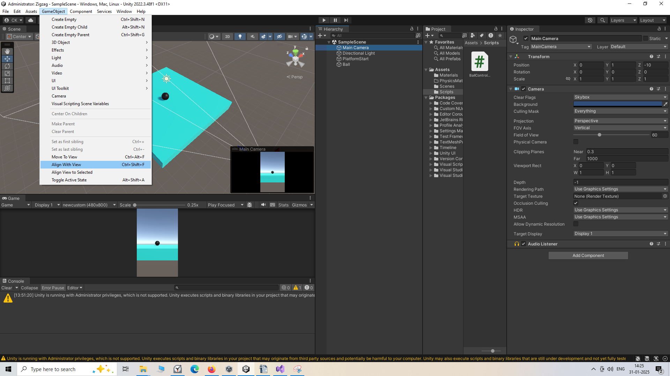
and then in subemenu click on align with View
Now by this our game panel will look same as the scene panel
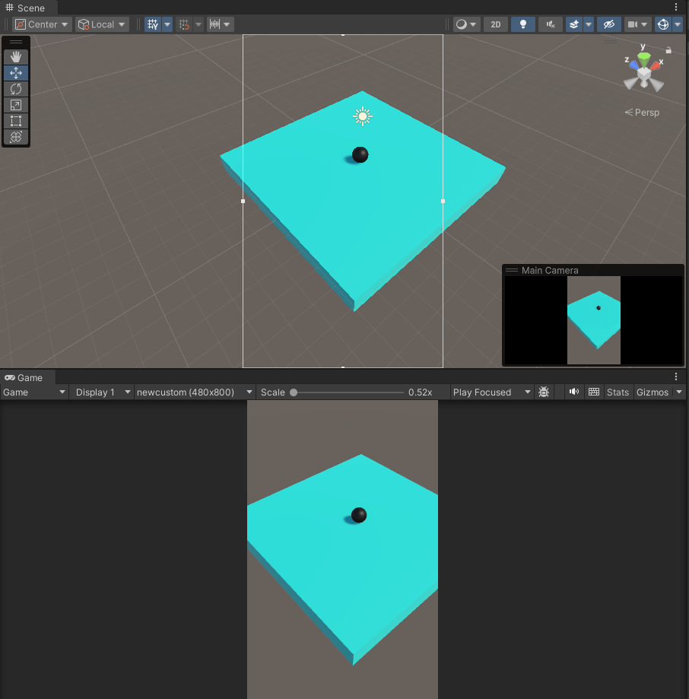
So now we can align or move the camera so that we can actually position in a position that we want

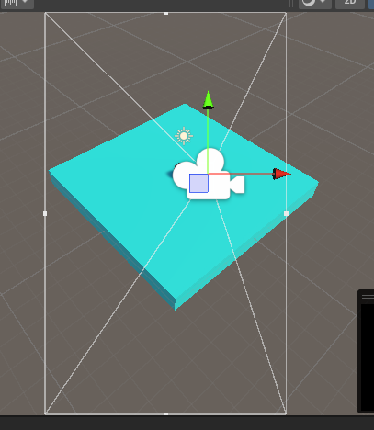
The white rectangle you can see above is signifying dimension of view to which you can see in the game panel or the plane the camera can move around (maybe)
if you do the align with view then scroll up to zoom out and you will see the similar interface above
now with move tool move the camera in 2D plane
In the next lesson we will learn about how to control the ball more and we can detect the ball from falling and we will generate random spawning plaform

